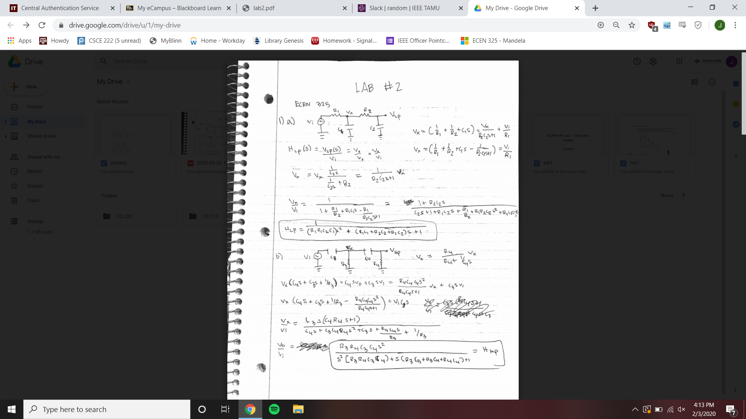

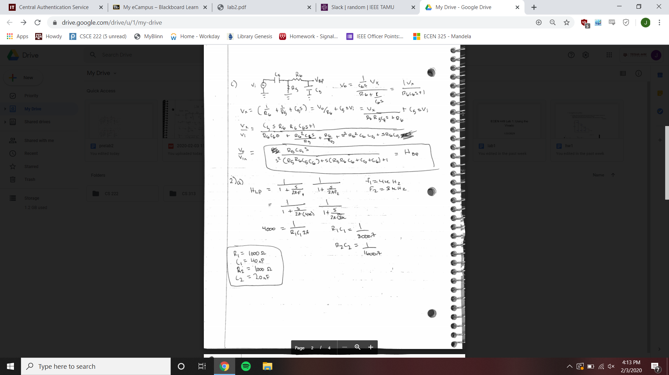

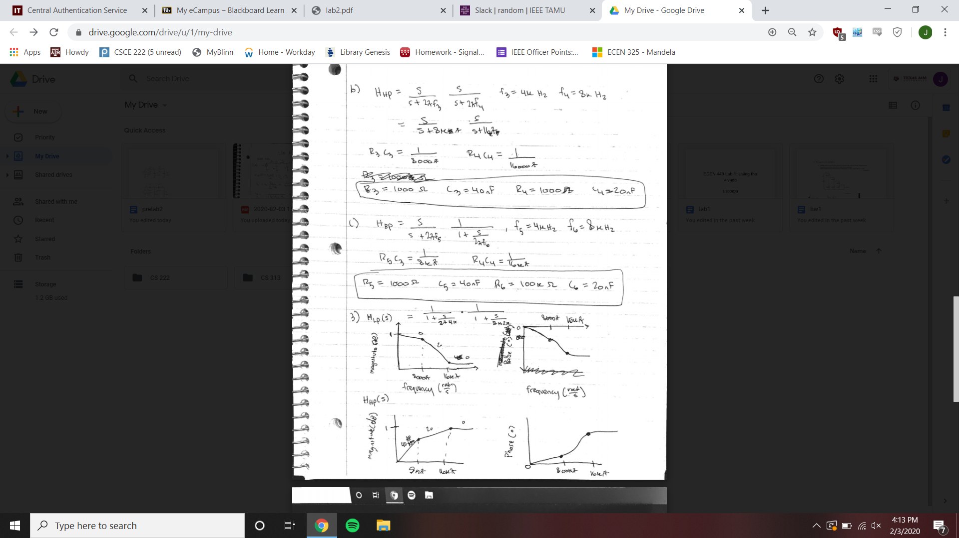

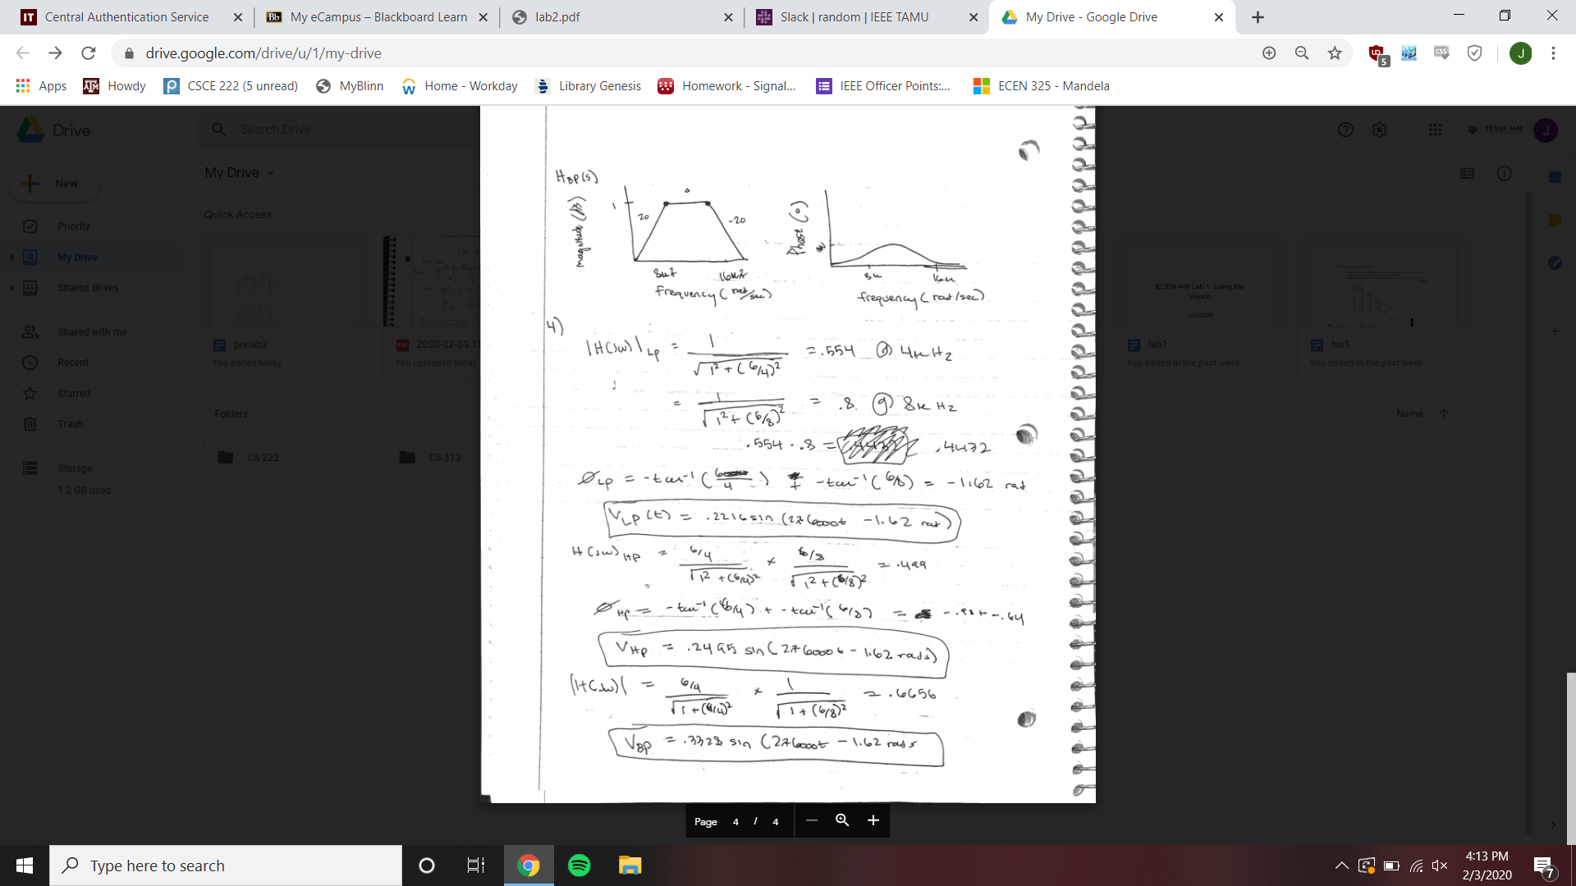

Schematics

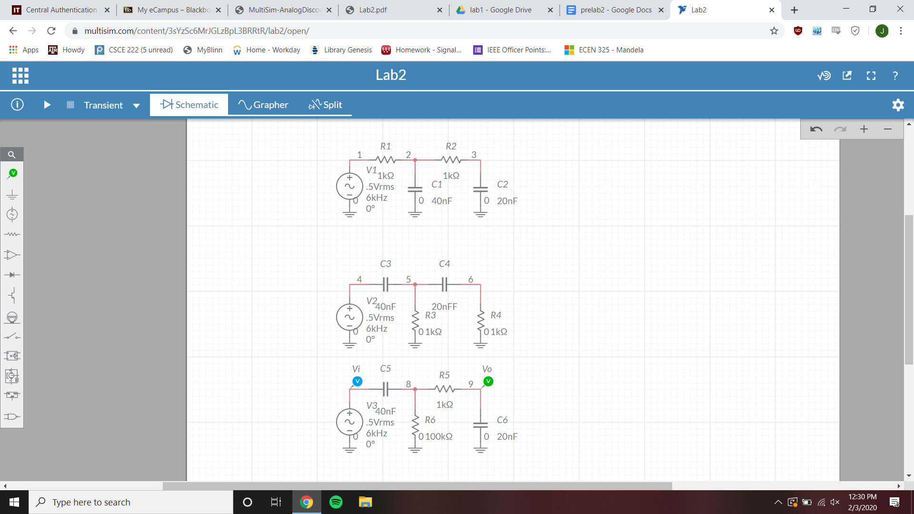

Low-pass Bode Simulation

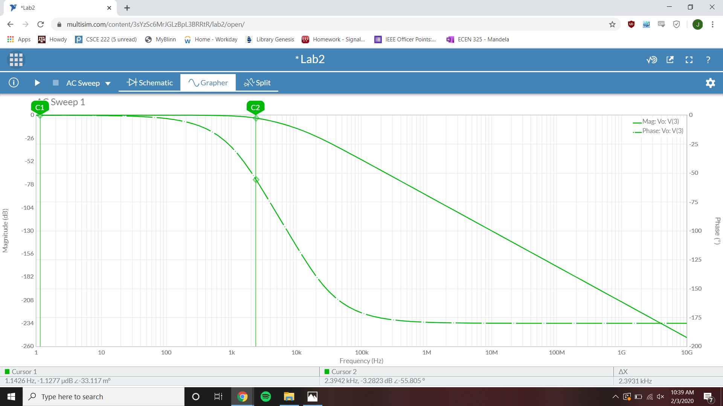

3 dB frequency = 2.3931 kHz

Passband gain = -1.1277 µdB

Magnitude @ f=6k Hz = -10.054 dB

Phase @ f=6k Hz = -94.639°

High-pass Bode Simulation

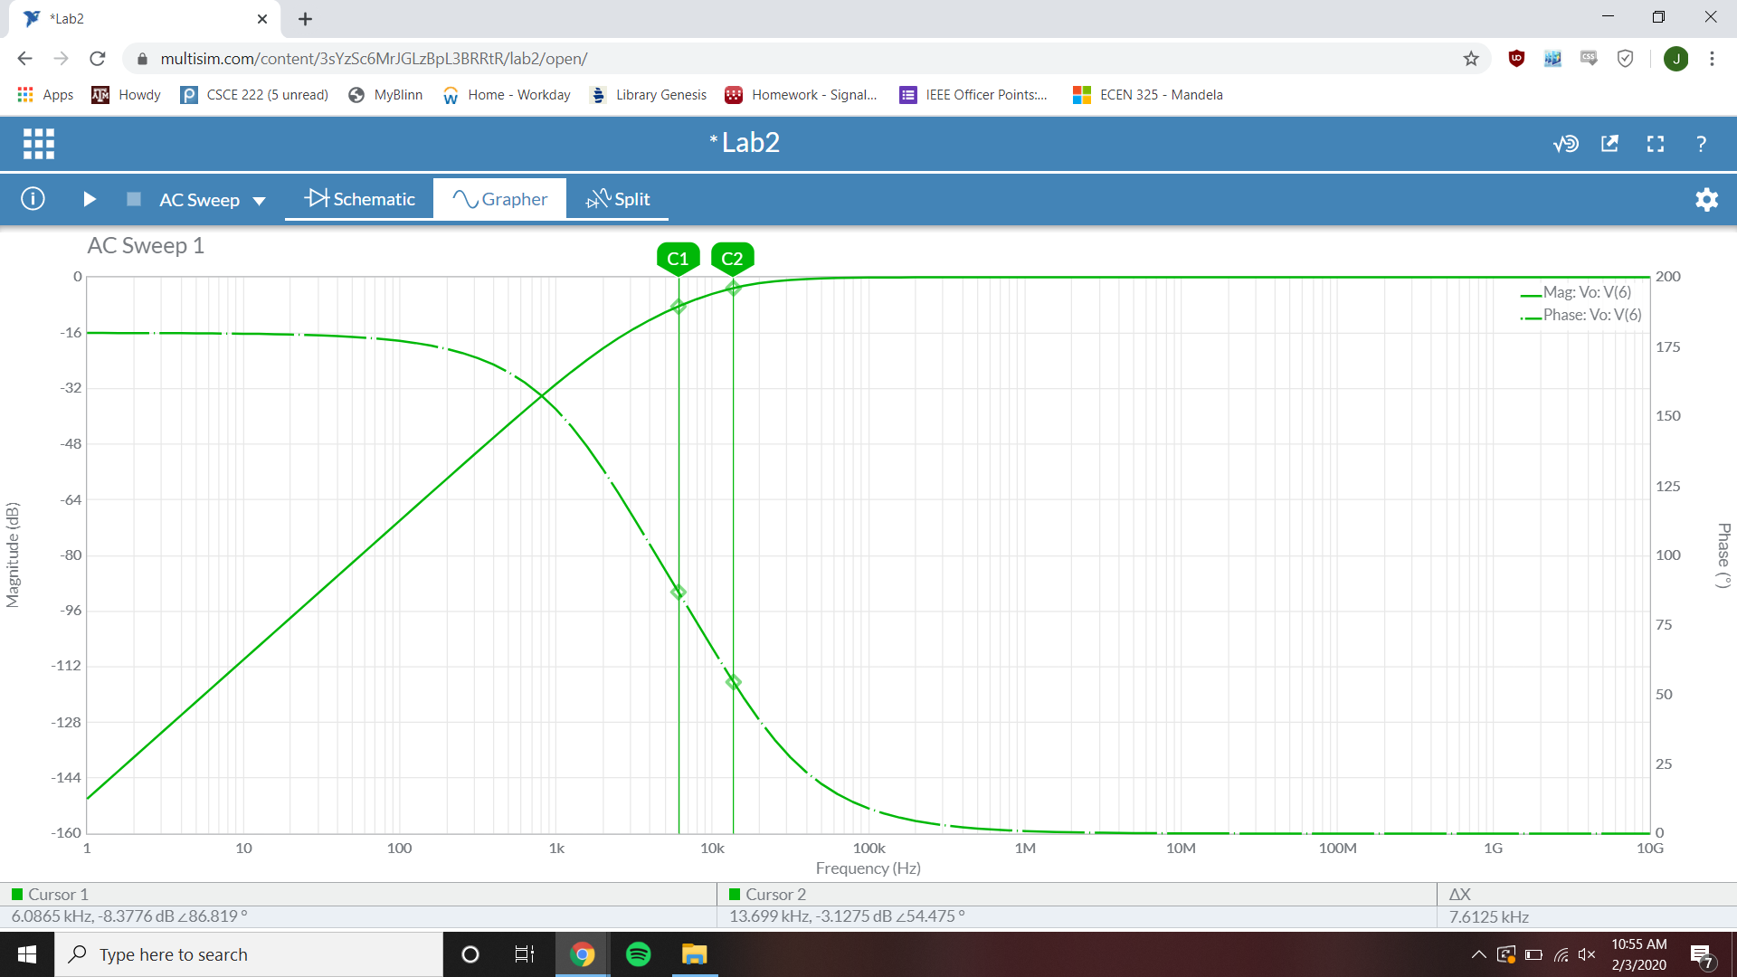

3dB frequency = 13.699 kHz

Passband gain = -2.7626 µdB

Magnitude @ f=6k Hz = -8.3717 dB

Phase @ f=6k Hz = 86.792°

Band-pass Bode Simulation

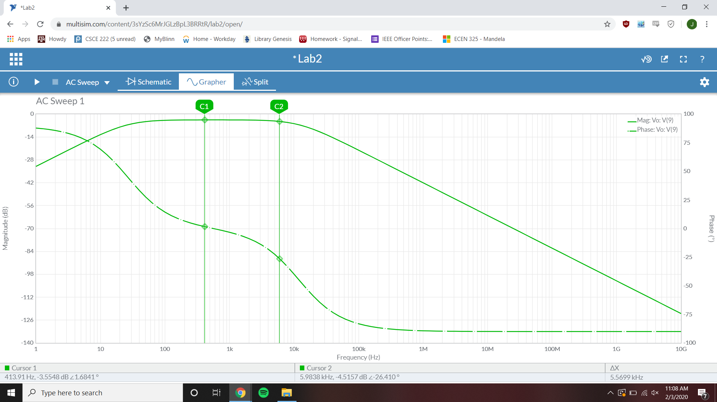

3dB frequency = 413.91 Hz

Passband gain = -3.5548 dB

Magnitude @ f=6k Hz = -4.5157 dB

Phase @ f=6k Hz = -26.410°

Low-pass Time-Domain Simulation

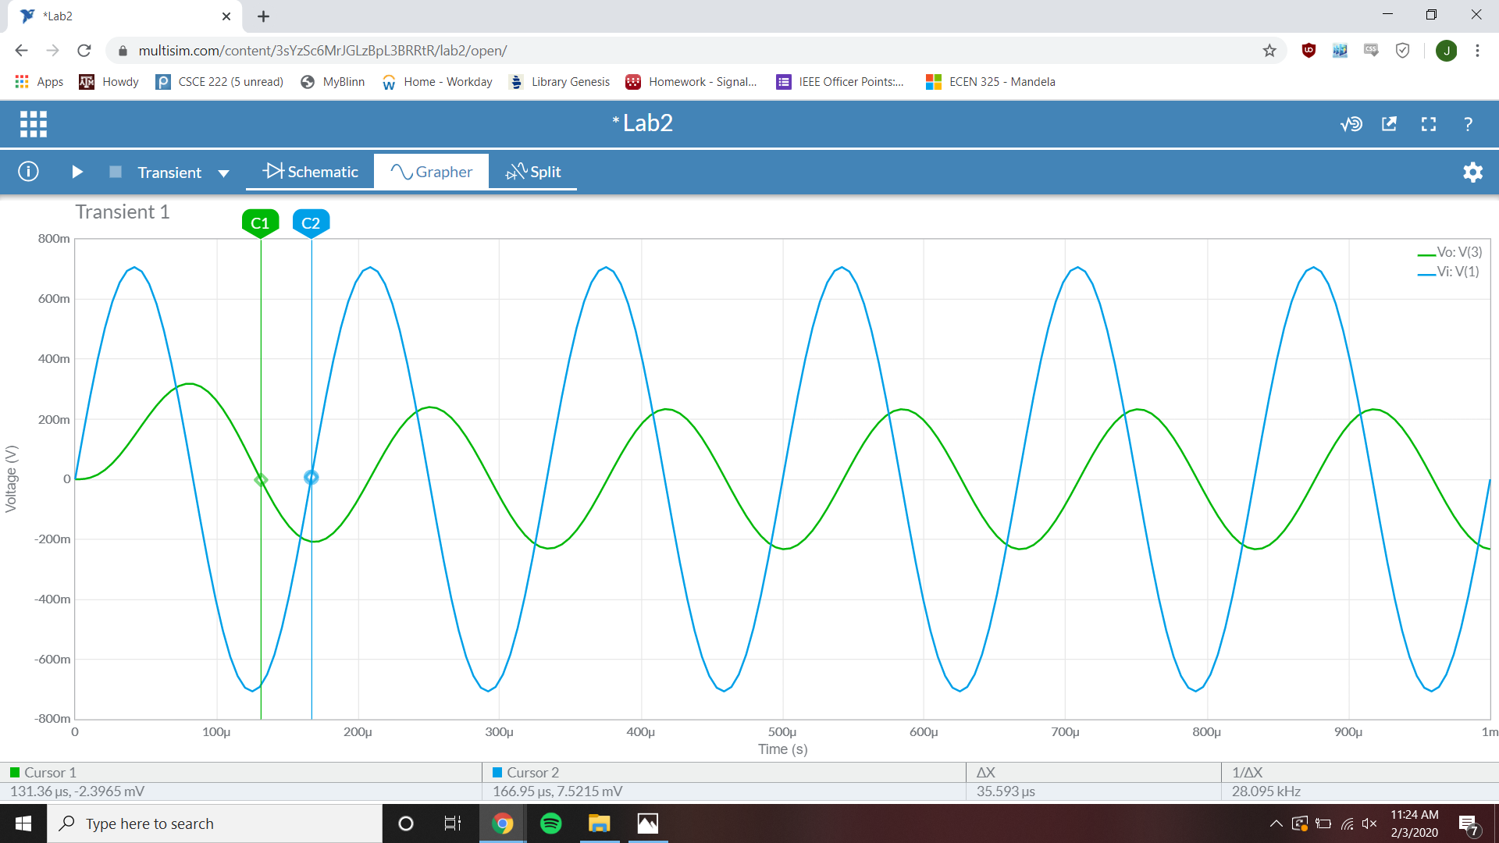

Phase difference = -76.8744°

Vi Magnitude = 706.22 mV

Vo Magnitude = 318 mV

High-pass Time-Domain Simulation

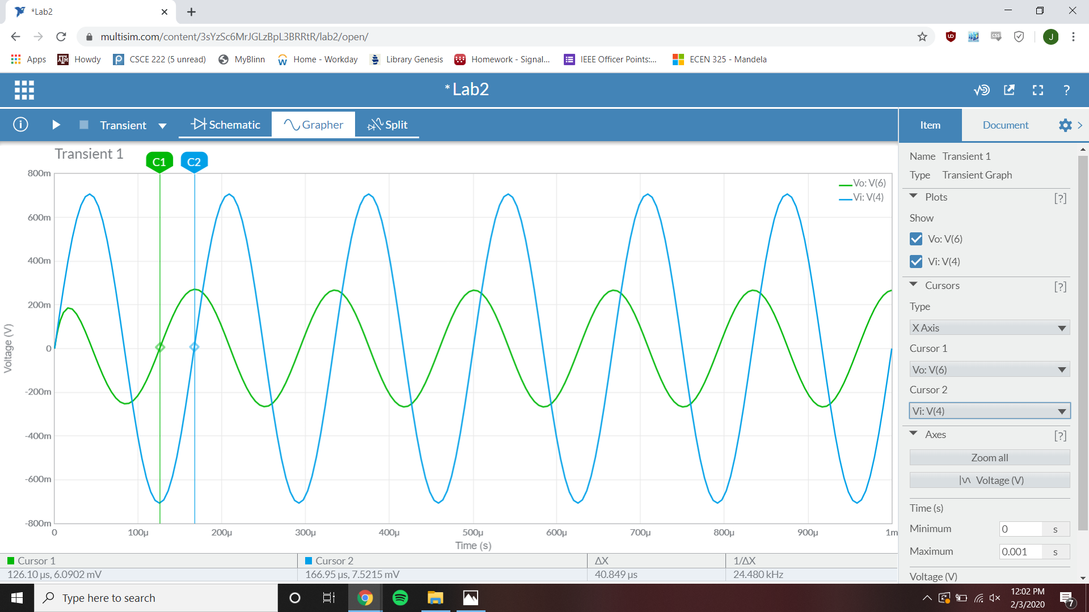

Phase difference = 88.236°

Vi Magnitude = 706 mV

Vo Magnitude = 270.83 mV

Band-pass Time-Domain Simulation

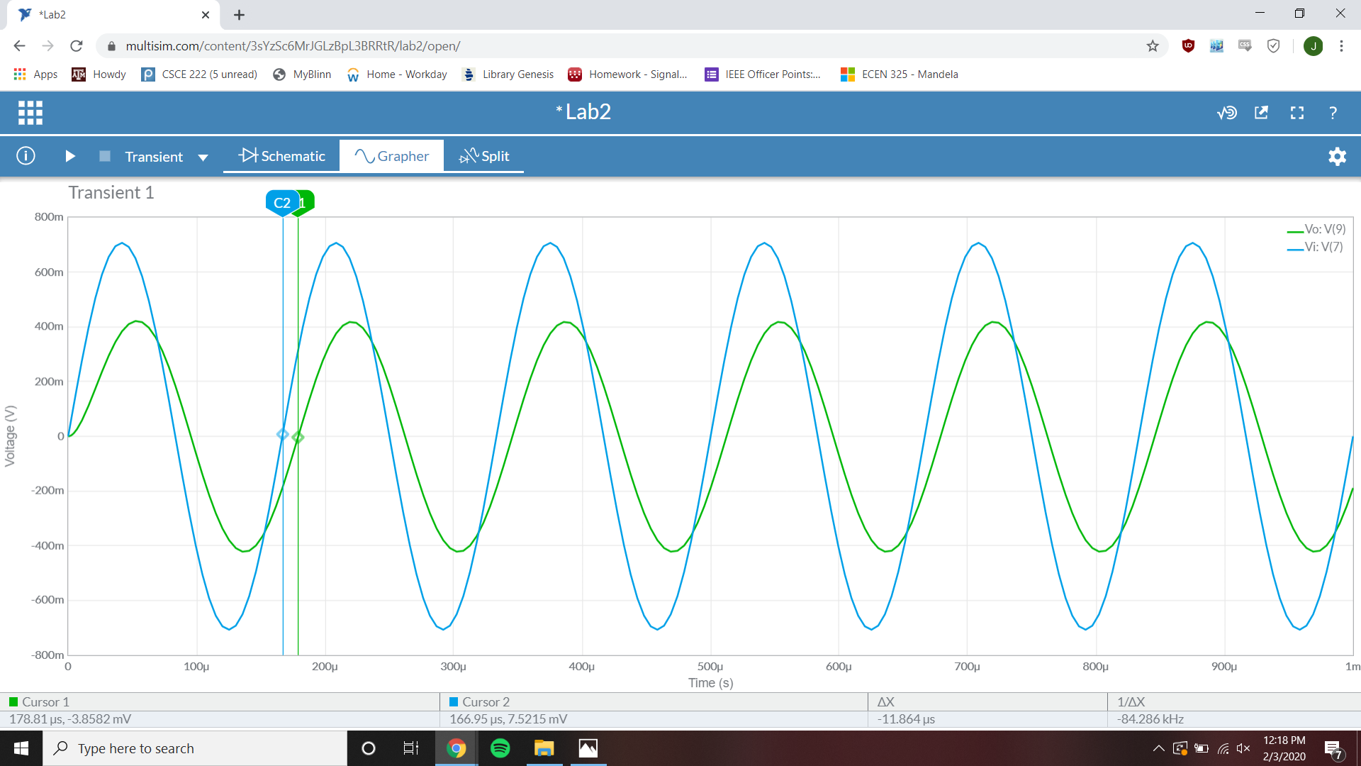

Phase difference = -25.73°

Vi Magnitude = 706 mV

Vo Magnitude = 417.2 mV